March 2018

Dear Parent/Carer
The new SIMS Parent App provides a convenient and accessible way for the school to communicate with parents. All of the information is easily accessible from the convenience of your phone or tablet. A web address is also available to access this information:
www.sims-parent.co.uk
Over 750 parents have now successfully registered. All short and full reports will be published on SIMS Parent moving forward. Therefore we recommend you register for the service at you earliest convenience. Please see the information on the reverse of this letter for details on how to register with SIMS Parent. If you have any difficulties registering, please contact the email address below and we will endeavour to respond as quickly as we can.
ParentAppSupport@walton.staffs.sch.uk
Thank you very much for all your valuable feedback while we have rolled out the App to all year groups. We have listened to this feedback and have changed the parent calendar so you should now only be shown events relevant to your child’s year group. Any further feedback from parents, both positive and negative, is much appreciated.
Future Developments…
There are some exciting new features coming to the Parent App. We are currently trialling the use of the App to communicate homework information and deadlines to parents. The trial has so far been successful and we have had positive feedback from the parents and students involved. We look forward to sharing more on this function soon. We are also looking to introduce a student version of the App which will allow your child to monitor their homework and key school events. We are looking to introduce this SIMS Student App in the not too distant future.
Many thanks for your continued support.
Yours sincerely

Mr G Smith

Parents/Students
- You will receive a registration email from noreply@sims.co.uk containing a unique invitation code. You will need this code to set up your SIMS Online Services account. If you have not yet received a registration email, please check your SPAM folder before contacting your school.

IMPORTANT NOTES: To register for SIMS Online Services products, you will need one of the following accounts: Microsoft, Office 365, Google, Facebook, Twitter.

- Follow the link in the email to be directed to the Sign in page.
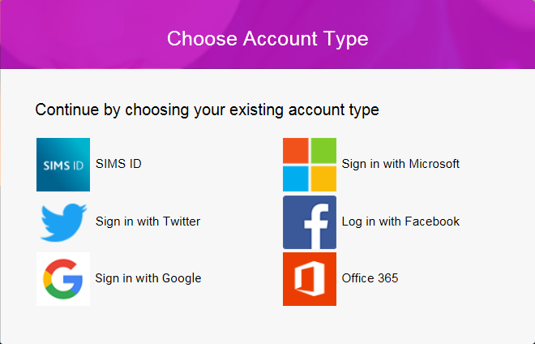
IMPORTANT NOTES: Parents and students must not attempt to register using SIMS ID. The SIMS ID option is for use by school staff only.

- Users should register with a Microsoft, Office 365, Google, Facebook or Twitter account. Click the icon for the relevant Third Party account and you will be directed to sign in using your existing details.

- Once registration has been completed successfully, you can access your children at this school.

What if I don’t have one of the email accounts listed above?
Many parents have email addresses ending @sky.com or @yahoo.co.uk or others. You can still use the App with these addresses, but it must first be registered together with one of the account providers above. We recommend registering a new account with Microsoft. Simply click on the Microsoft button and you will see an option called ‘create account’. This will allow you to create an account with Microsoft using your existing email address which you have registered with SIMS and the school. Follow the instructions to register with a Microsoft account and you will eventually be prompted to enter your verification code.

